HC 1 T3 U1
 | 題目 | 圖片
1 | What's wrong?  I'm thirsty. | 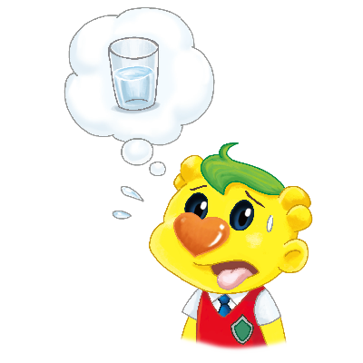
2 | What's wrong?  I'm hungry. | 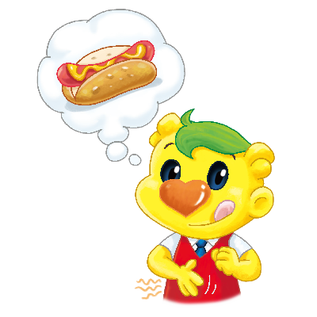
3 | What's wrong?  I'm sick. | 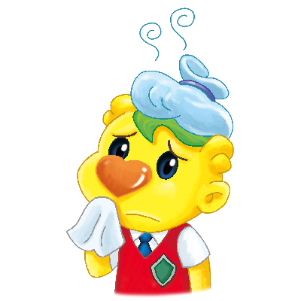
4 | What's wrong?  I'm tired. | 